Student Activity
16 Force and equilibrium

TASK
To investigate the conditions necessary for equilibrium.

THEORY
For forces acting at a point to be in equilibrium, ΣF = 0. That means that the sum of all vertical force components must equal zero and the sum of all horizontal force components must equal zero,
i.e. ΣF_{V} = 0 and ΣF_{H} = 0.
The force required to balance any two forces acting at a point can be found by adding the vertical and horizontal components.

EQUIPMENT
• force tables or boards on which to fasten balances
• circular key ring
• string
• three spring balances
• rule
• protractor
• plain paper
• drawing pins

NOTES ON METHOD
1. Connect a short piece of string to each of three spring balances, then tie each piece to a central circular key ring.
Fix the ends of the spring balances to a force table or board so that no two balances have the same reading.
You will find this easiest if all three pieces of string are different lengths.
Adjust the strings so that each balance pulls in a line through the centre of the ring.
Fix a piece of plain paper onto the force board beneath the balances.

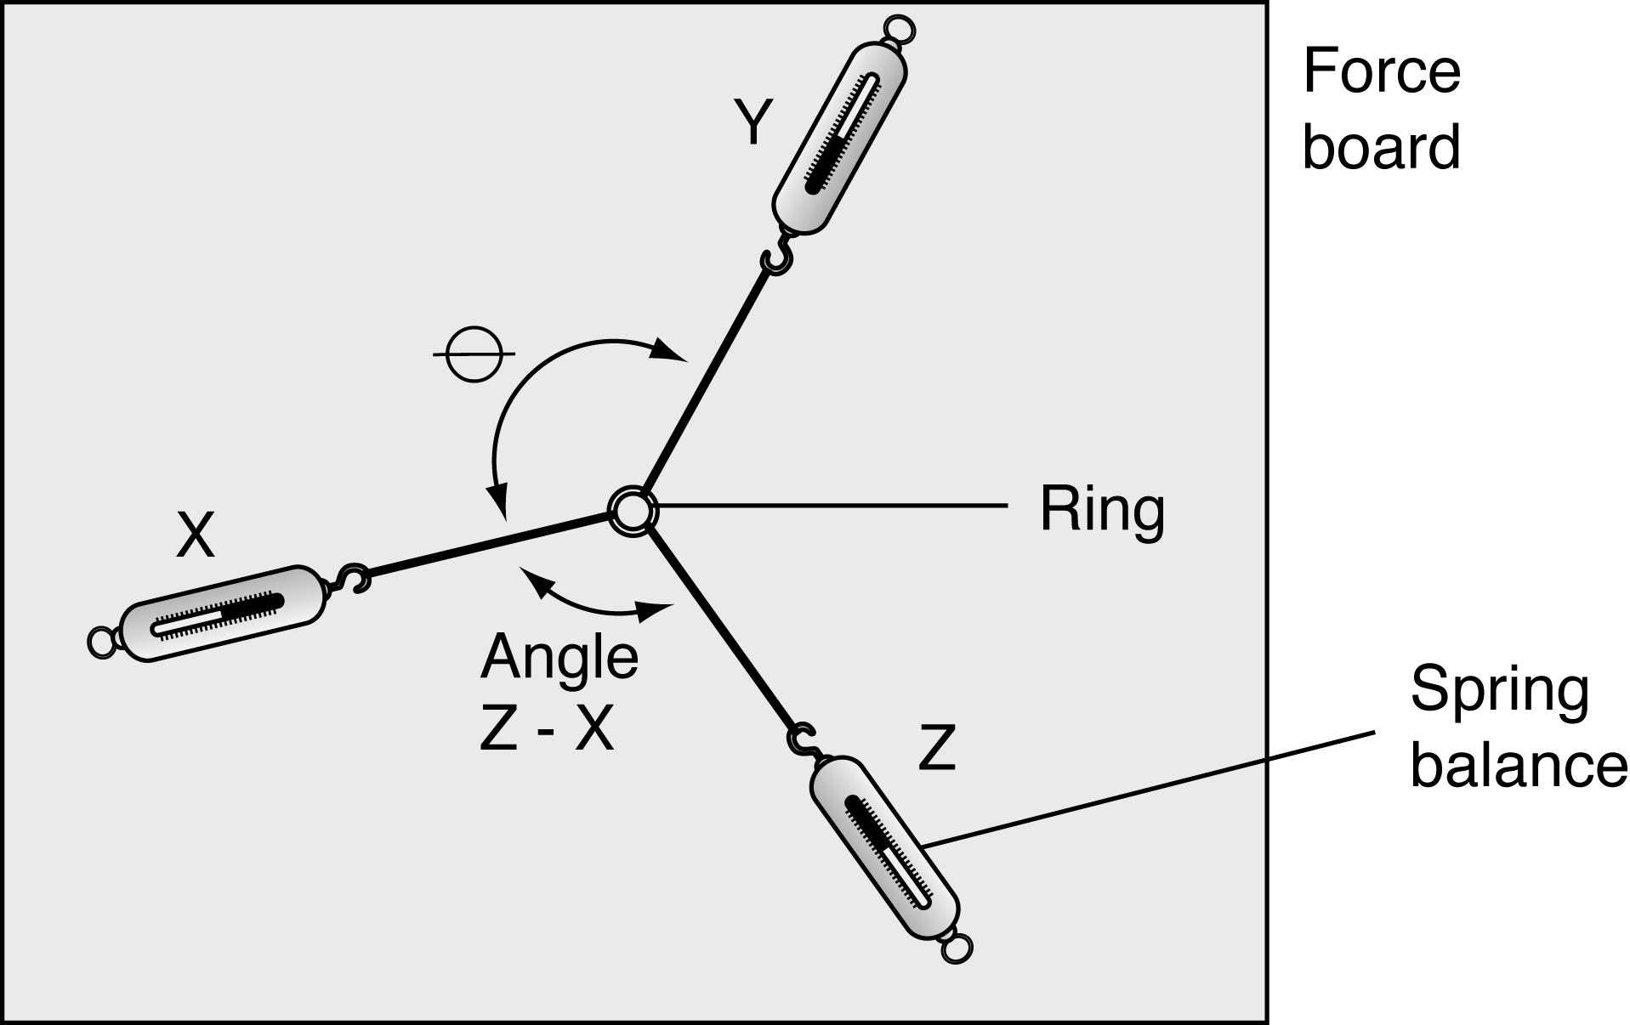

2. Identify the spring balances as X, Y and Z and read off the magnitudes of the three forces in newtons.
Make sure that you allow for any zero error in the balances.

3. Use a rule and pencil to trace the strings attached to each force sensor, and thus the direction of the forces.
Trace all three lines through until they meet in the centre.
Measure θ, the angle between forces X and Y, with a protractor.

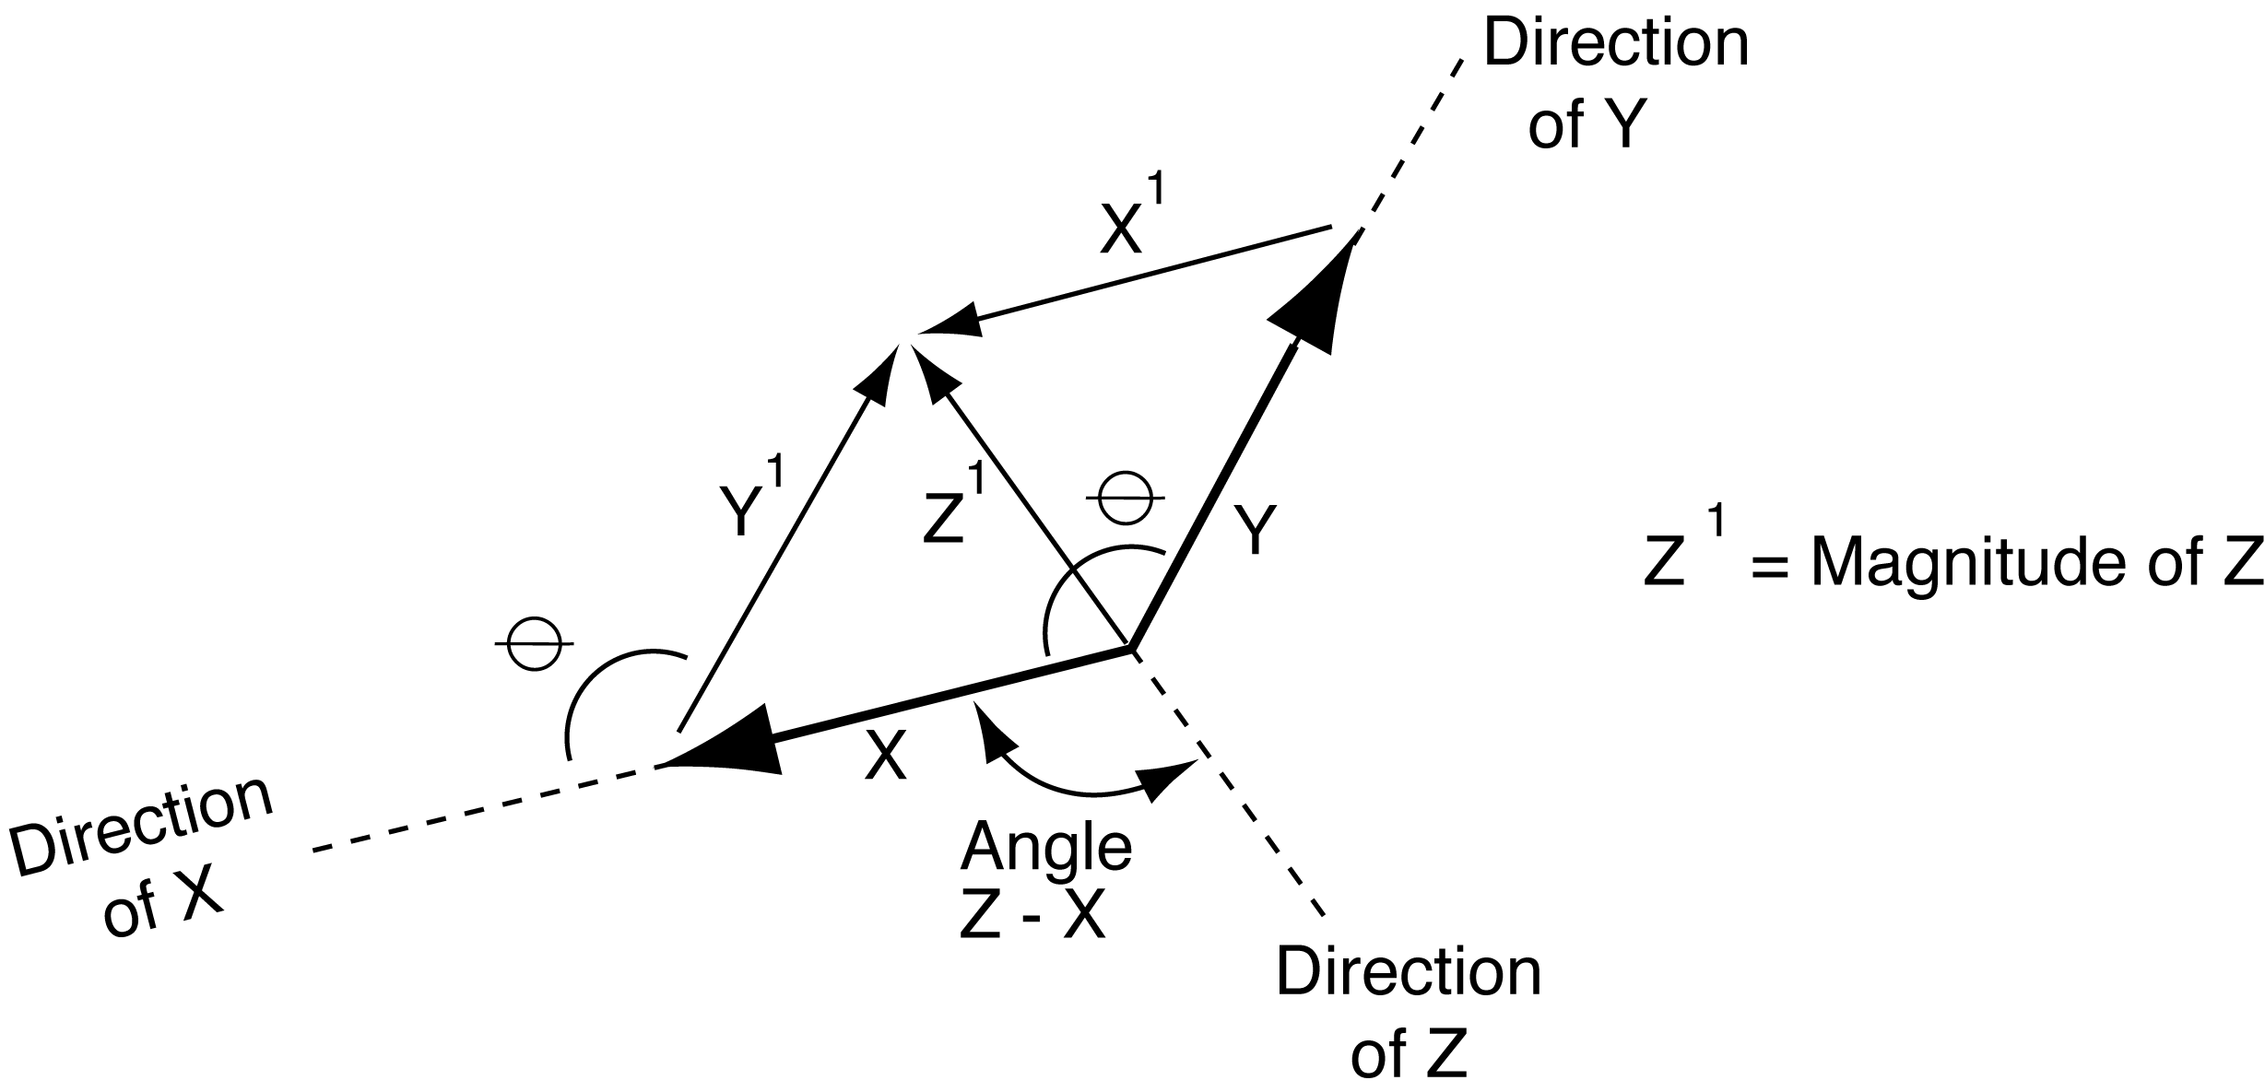

4. Repeat steps 1–3 three times with different forces and different angles between them.
continued
16 Force and equilibrium
DATA & ANALYSIS
Force Z can be found by calculation or vector diagram based on your measurements of the angle between X and Y, and the relevant magnitudes.

Find the magnitude of force Z and the angle between it and force X using this method for each of your three trials.

Compare your results for each trial:
Observed magnitude of Z: ………………… N
Measured magnitude of Z from force diagram: ………………… N
Observed angle Z–X: ………………… °
Measured angle Z–X: ………………… °

CONCLUSION
How do the observed and measured values for the magnitude and direction of Z agree?
Summarise your results and the reliability with which you feel this method could be used to determine an unknown force.

QUESTIONS
1. Under what circumstances will forces X, Y, and Z be equal in magnitude?
2. What are the sources of error in this experiment?

